# **Name: Abdurrahman Qureshi**

# **Roll No: 210451**

Practical No: 20

**1)** **Define a package named myInstitute include class named as department with one method to display the staff of that department. Develop a program to import this package in java application and call method defined in the package**

**CODE:**

**PACKAGE FILE**

package myInstitute;

import java.util.*;

import java.lang.*;

public class PackageStaff{

public void ShowStuff(){

System.out.println("JAVA = PIC - Annoying\nGAD = WPD - Good\nMIC <<<<< BCC,EEC,DTE - Headache\nDCC = CPH (with extreme theory)\nSEN == Most boring shit ever");}}

**MAIN FILE**

import myInstitute.*;

import java.util.*;

import java.lang.*;

class PackageStaffCalling{

public static void main(String[] args) {

PackageStaff P = new PackageStaff();

P.ShowStuff();}}

**OUTPUT:**

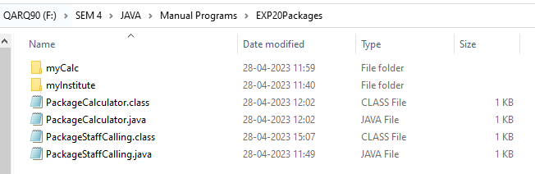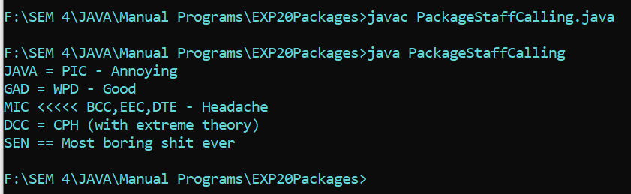

**2) Develop a program which consists of package named let_me_calculate with class named calculator and a method named add to add two integer numbers. Import let_me_calculate package in another program (class named Demo) to add two numbers**

**CODE:**

**PACKAGE FILE**

package myCalc;

import java.util.*;

import java.lang.*;

public class PackageCalc{

public void CalcStuff(int a , int b) {

System.out.println("\nA + B = " + (a + b) + "\n");} }

**MAIN FILE**

import myCalc.*;

import java.util.*;

import java.lang.*;

class PackageCalculator{

public static void main(String[] args) {

PackageCalc P = new PackageCalc();

P.CalcStuff(10,20);}}

**OUTPUT:**



